Not Able and Not Available: the Other Reasons
Ineke Stoop (SCP), Hideko Matsuo (Leuven University) and Achim Koch (GESIS)
Paper for the 2012 Nonresponse Workshop in Ottawa

What are we talking about?
In nonresponse research refusal and noncontact are usually identified as the major reasons for nonresponse. There is a third category (“not able”) but usually very little attention is paid to this. In the European Social Survey three categories of nonresponse are usually distinguished: refusal, noncontact and “not able/other”. Figure 1 shows that this last category accounts for a substantial part of the nonresponse.

Figure 1.Final disposition codes, European Social Survey Round 1 to Round 4 (only countries that participated in each round). Source: Matsuo et al. (2010, p. 55).

Figure 1 presents for those countries that participated in the first 4 Rounds of the ESS, response (=interview), noncontact, refusal and not able/other as a percentage of the eligible sample units. Not able/other comprises four categories from the so-called contact forms used in the ESS (see an extract in figure 2): not able mentally or physically (cat. 6), not able, language barrier (cat. 11), unavailable/not at home during fieldwork period (cat. 5), and “other” (cat. 12).

Figure 2. Recording outcomes of contacts in the ESS R4 contact form
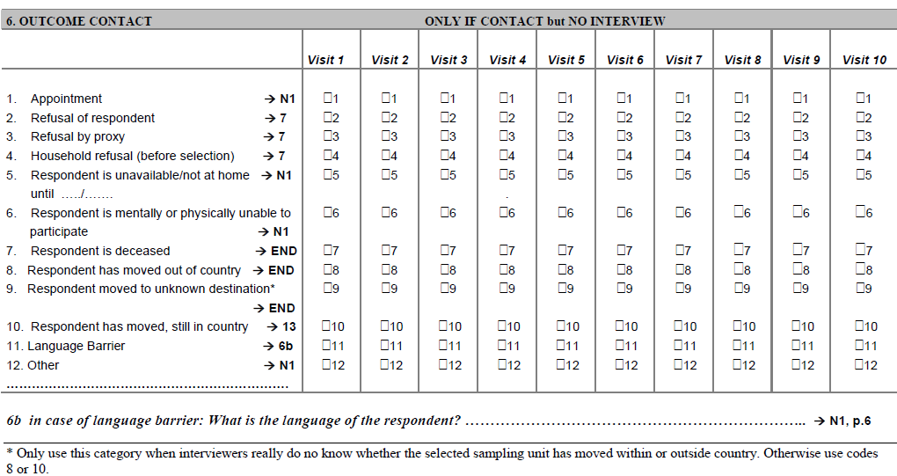
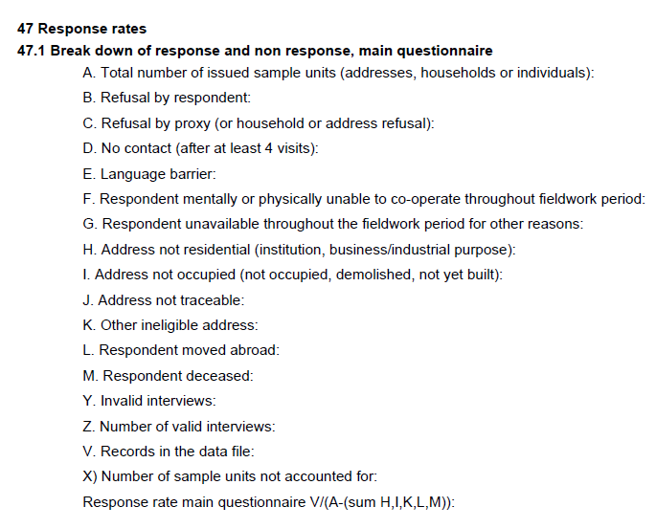
Figure 3. Calculation of response rates in European Social Survey Round 4
In the ESS the outcome of the last call is used as the final disposition code with two exceptions: 1) after a refusal – even if the last contact attempt resulted in non‐contact or another outcome – they final outcome was refusal, they were declared refusal, and 2) a refusal by the respondent overrules a refusal by proxy. Figure 3 shows how the response rate is calculated in the ESS. The number of eligible sample units is the total number of issues sample units minus non-residential addresses, not occupied addresses, other ineligibles address, and respondents who have moved (permanently) abroad or have deceased (H,I,K,L,M). Refusal (B,C) can be by the respondent or by someone else in the household (or a refusal to select the respondent from the household members)). No-contact with anybody in the household is a noncontact (D). The respondent may not speak the survey language(s) (E) or be unable to cooperate mentally or physically (F) (not able), and the respondent may be unavailable for other reasons (G) (unavailable + other).

As the combination “not able/other” is so substantial, it is worthwhile to check the details, available from the ESS data website (NSD, 2010, 2012). This report presents the disposition codes as calculated by the countries themselves. These codes may differ from the standardised ESS disposition codes (see below). Figure 4 presents the outcomes for language barrier, mental or physical impediments and unavailable/other for ESS R4. Countries are ordered by response rate (46% in Croatia, 79% in Cyprus).

Figure 5. Language problems, mentally or physically unable, and unavailable as percentage of eligible sample units, ESS R4 (NSD, 2010)

The first striking outcome is the very large differences in the percentage of people who are unavailable throughout the entire fieldwork period or did not participate for other reasons (14% in Romania, close to 10% in Slovenia and Switzerland, and in 12 out of 30 countries less than 1%).
Figure 6 gives the same picture without the “unavailable/others”. Here we see again the substantial variation between countries: some countries record no language problems at all, whereas they are a substantial problem in Cyprus and Belgium. Also, in some countries nobody is unable to participate due to mental or physical impediments, whereas in Germany, Denmark, Estonia, Belgium, Norway, Sweden, Finland and Poland this is 2.5% or more.
At a country level, the correlation between “language barrier” in R4 and R5 is .94, between mentally or physically unable .82, and between unavailable/other .21 (the correlation between response rates is .74). The different patterns for unavailable/other are illustrated in figure 7.
From these figures it is clear that “not able” is a sizeable factor behind nonresponse in some countries, almost non-existent in other countries, and should not be ignored. It is also clear that “not available/other” can be a large factor, may be confounded with noncontact and is hard to interpret.

Figure 6. Language problems, and mentally or physically unable as percentage of eligible sample units, ESS R4 (NSD, 2010)

Figure 7. Not available/other in ESS R4 and R5 (NSD, 2010, 2012)

What can cause the differences between countries?
There are several reasons why the “not able/other” rates could differ across countries.

- Real differences
Firstly, of course there could be real differences between countries. For instance, in emigration countries one could expect more people to be unavailable during the entire fieldwork period. An argument against this is the low correlation between R4 and R5, and the fact that traditional emigration countries do not stand out here, as the “unavailable/other” rate is also pretty high in Finland and the UK. The high correlation between language problems in both rounds could indicate that these language problems are a characteristic of the population. This correlation could also be due, however to other organisational factors (see below).

- Incorrect definition target population
There is some evidence that occasionally “not able” groups are removed from the total number of sample units. E and F would then be counted as ineligible, and the response rate would artificially be enhanced.

- Calculation final disposition codes
In the ESS countries calculate final disposition codes, and deliver their Contact Form data to the Archive. From these forms standardised outcomes are calculated according to the priority scheme mentioned above. A refusal followed by a noncontact should be coded as a refusal, for instance. At present there are in some cases substantial differences between the national disposition codes and the standardised, centrally calculated codes (although the same priority scheme should be followed). Sadly, not all countries provide contact forms that are of good enough quality and complete enough to calculate standardised outcomes.

- Sampling frame
ESS countries use individual, household and address sample, depending on the best alternative available. It could happen that in non-individual samples it is much easier to substitute someone (undocumented) for an unavailable or unable household member. The percentage of unable seems to be higher in countries that use individual samples.

- Recruitment mode
In countries using individual samples and good coverage in the telephone register (e.g. FI, NO, SE), respondent recruitment may be conducted by telephone. It could be that unavailable or unable is more easily said and/or accepted over the telephone.

- Contact form and language
The contact form is translated in every country except the UK and Ireland. Some countries use a proprietary form and have to translate their outcomes to the ESS categories. This means that the meaning of the categories may differ across countries, e.g., what is meant by being mentally or physically unable to cooperate may differ across countries (see text CFs round 5 in French-speaking countries).
Belgium | R est mentalement ou physiquement incapable de coopérer
France | Tout le foyer est mentalement/physiquement incapable de répondre
Switzerland | 10) Mentalement ou physiquement incapable de coopérer durant la période de recherche sur le terrain
 | 11) Malade, mais d'accord plus tard (Rendez-vous)

- Fuzzy terms and interpretation interviewers
- It is not entirely clear what it means that the respondent is unavailable during the entire fieldwork period. The Contact Forms phrase it differently: respondent unavailable/not at home until... Could this mean the period a particular interviewer handles the case?
- What is the difference between unavailable and a noncontact. According to the AAPOR guidelines we should code a noncontact when the target person is unavailable during the entire fieldwork period. Now “unavailable” is confounded with several other factors.
- Language problems could be an easy way out for the respondent. Saying you don’t speak the survey language (good enough) protects the target person from having to explain to the interviewer why they don’t cooperate. The same could hold for being ill.
- It is not clear whether interviewers go back or have to go back when they called on somebody who was mentally or physically unable to cooperate. The new contact forms for Round 6 now distinguish between short-term and long-term illness.
- In general, “not able” could be due to having a deadline to keep, cooking dinner, bringing children to bed, caring for a sick family member, etc. Although the text says “mentally or physically unable during the entire fieldwork period” the “unable” could be used more generally.

- Interviewer evaluation and bonuses
Interviewers are often evaluated according to their success. An interview is obviously a success, a refusal and a noncontact clearly not a success. When the respondent is unable or unavailable the interviewer is of course not to blame. So there is clearly an incentive to minimise refusal and noncontact, and to maximise not able and unavailable, especially as these categories do hardly get any attention in the ESS and the nonresponse literature.

Conclusion
We should – whenever possible – calculate final disposition codes at a detailed level based on the contact forms. We should also get in touch with National Coordinators and national fieldwork teams in order to try to find out how fieldwork implementation can affect “unable” and “unavailable” (and other call outcomes) and how interviewers are instructed and interpret the outcome codes.

Questions
- Is “not able” really a substantial cause of nonresponse?
- If so, what should and what can we do about this?
- How can we standardise the final disposition codes?
- Do others have experience in this area?
- How do other surveys handle this problem?

Matsuo, H., J. Billiet, G. Loosveldt & B. Malnar (2010) Response‐based Quality Assessment of ESS Round 4: Results for 30 Countries Based on Contact Files. Onderzoeksverslag Centrum voor Sociologisch Onderzoek. CeSO/SM/2010‐2.
NSD (2010) ESS4 2008 Documentation Report. The ESS Data Archive. Edition 4.0.
NSD (2012) ESS5 2010 Documentation Report. The ESS Data Archive. Edition 2.1.

