Results of the (new) International Questionnaire on Non-response: response of the LFS and other surveys

Annemieke Luiten, Edith de Leeuw and Joop Hox²

Introduction
Many survey researchers claim that response rates have been steadily falling over the last decades. There are a few international overview studies, but they are either somewhat outdated or tell an incomplete story. Over the last two decades the communication with survey respondents has changed to a wide variety of survey modes and combinations of survey modes. Do these changing data collection methods result in a different picture?
During the 2015 Workshop, it was decided to revive the comparison of international time series of response rates (De Leeuw and De Heer 2002) and perform a new investigation into response rate.
The first initiative to compare international data on non-response was taken in the first Workshop on Household Survey Non-response in 1990. Data collection was performed yearly from 1991 to 1997. In the first year, retrospective time series were inventoried. The 16 NSI’s that participated provided data from time series as long back as 1972. De Leeuw and de Heer (2002), who analysed the data of these time series , showed that response rates declined over the years, with refusal rates increasing with 0.3% per year, and contact rates declining with 0.2% per year.
The analysis also showed that there were substantial differences between countries and surveys in the amount of (non-)response, refusal and (non-)contact. The original Non-response Questionnaire was designed to shed light on these differences, by inventorying relevant design aspects like rules of respondent selection, refusal conversion, substitution or interviewer employment.
The new Questionnaire replicated the old one as far as relevant, and added elements like mixed mode data collection, fieldwork effort and fieldwork costs. The (paper) questionnaire was sent to all European NSI’s, as well as some non-European other countries, like Australia, New Zealand, Canada and the USA. We tried to include non-NSI’s in the query, and succeeded in a number of cases. NSI’s were asked to provide data for the Labour Force Survey (LFS) and one other survey. At the second reminder, we asked for the LFS data only.
Respondents were asked to report on the response, refusal and contact rates from 1998 to 2015. For respondents who were also present in the first query, we thus created a long time series. In order to limit the respondent burden, we asked for a description of the 2015 design, and asked respondents to indicate if, and in which years, design changes were implemented.

Results
More countries participated in this query than in the first one: 16 then, 25 now. Two time series were received from non-NSIs. Not all respondents were able to complete the entire time series, although the number of years filled in was substantial for most: mean number of years filled in was 15. All respondents reported on the LFS, 13 countries also reported on other surveys, mostly on the HBS (8), but also on the Survey of Income and Living Conditions (3) and four other surveys. Finland outdid us all by filling in five questionnaires.
In the first analysis, presented at the workshop in 2016, we concentrated on the findings on the response rates of the LFS (or non-European equivalent surveys). In the present paper we also include the other social survey provided. We differentiate between voluntary and mandatory surveys, as levels and trends proved to be different in the earlier analyses. In the new data, we see this difference again: Table 1 shows mean and range of response, refusal and noncontact rates for mandatory LFS, voluntary LFS and the collapsed voluntary other survey.

Table 1. Response, refusal and noncontact rates for LFS and other survey; mean and (range)

Response trends LFS
We ran a series of multilevel repeated measures models on response, refusal and non-contact data, first on logit transformed data, but also on proportions, to help interpretation. Both analyses show the same pattern, so we report on the proportions (reported as percentages) here. For all three outcome variables, we ran a multilevel regression model using REML estimation in the MIXED procedure of SPSS 21. Predictors were occasion (year), transformed so that 1998=0 (start of new data collection), and whether the survey was mandatory or not. All results are significant (except one marked ns) and in the expected direction: response went down over the years, refusals and noncontact rates went up, with comparable extent. Mandatory surveys have higher response rates, and lower refusal rates. The difference in noncontact is not significant.
Table 1. Model on raw outcomes
Model: | Response | Refusal | Noncontact
Fixed part | Coefficient | Coefficient | Coefficient
Intercept | 54.85 | 28.00 | 14.45
Occasion (year) | -7.28 | 3.36 | 3.36
Mandatory | 12.62 | -11.36 | -1.28^{ns}
Random partª
 | 6.50 | 2.01 | 3.17
 | 72.24 | 67.25 | 45.19
 | 30.09 | 16.28 | 14.78
ª For simplicity the covariances are not included

Comparison with de Leeuw and de Heer data
We combined the de Leeuw and de Heer data with the new data in a single data file, including countries that exist only in one of the two data collections. The results show that for response the difference in year trends between both data sets is not significant, p = 0.50 (two-sided Wald test for difference, cf. Guilford & Fruchter, 1978, p148). When only data are analysed that exist in both data collections, the results are very similar. Likewise, there is no difference in year trends between the old and new dataset for refusals (p = 0.27) and noncontacts (p = 0.98). These results mean that the trends reported by de Leeuw and de Heer have continued over the years. The noncontacts and refusals are increasing, and the response is decreasing at the same rate as reported in the earlier study. Translated into percentage points for the entire combined period, per decade (ten years) the noncontacts are predicted to increase by 2.94 percentage points, the refusals are predicted to increase by 2.52 percentage points, and the combined effect on the response rates are a predicted decrease of 7.31 percentage points. The analyses also showed that, although there are large differences between countries in the amount of response, refusal and non-contact, there are only very small differences between countries in the speed at which response , refusal and contact rates decrease.
The appendix shows the results of the multilevel regressions on response, refusal and noncontact, and graphs based on linear regression for each country separately. Note that, because of the small number of observations per country the regression lines have large standard errors. The differences in these graphs are therefore exaggerated. The multilevel analyses actually indicate small differences in the rate of change.
The multilevel analyses of the other social survey have not yet been done. Figure 4 in the appendix shows graphs for the response of the various surveys. Crude analysis indicates that the decline in response in most countries is the same as for the voluntary LFS. However, there are some countries where no decline is witnessed. In the next paragraph we analyse if we can find the driving mechanisms behind those differences.

Predicting response rates: LFS
One of the aims of the analysis is to explain differences in response rates between countries and to explain differences in response tends. The first analysis deployed multilevel analysis with years nested within countries. We defined three groups of predictors: (1) mandatory vs voluntary; (2) General Design Variables: mixed mode (yes/no), sample (hh, person), substitution allowed, proxy allowed (3) Fieldwork Design Variables: refusal conversion, incentives, interviewer reward, monitoring, intervention in fieldwork . These may slightly differ for predicting response, refusal and noncontact (e.g., the sampling related variables: substitution allowed refusal, allowed noncontact).
The analyses of correlates of noncontact only showed that the non-contact rate is higher in countries that deploy a mixed mode design, and that non-contact is lower when interviewers are monitored. The analysis of refusal showed that refusal rates are lower when surveys are mandatory, and when interviewers are monitored. The analysis on response rates showed that response rates are higher when surveys are mandatory, lower when mixed mode designs are used, higher when interviewers are monitored, and lower when incentives are used.
Because these analyses where not quite informative enough to explain all the differences we see between countries, we decided to explore the residuals to look for within country explanations. On the combined dataset a multilevel analysis was carried out with year and mandatory as predictors and the logit response as dependent variable. Estimation was carried out in MLwiN 2.25 using RIGLS. The standardized residuals for the intercept and slope were merged with the aggregated country variables. The residuals were controlled for the survey being mandatory or not and the trend across years.
The intercepts shows three outliers: Austria, Australia and Germany, who all have a relatively high response rate. Table 2 shows the correlation of the residuals with a large number of variables from the new dataset, because these variables are not available in the de Leeuw and de Heer data. Most of these variables do not change over the years, and are effectively country level variables. The table shows very few significant correlations. Calling mobile phones has a negative effect on the slope residual, which means that including mobile phones is related to a sharper decline in the response rate. We interpret this as a reaction to declining responses in CATI surveys, and not as a causal effect of including mobile phones. The maximum number of visits in CAPI and using freelance interviewers have a positive effect on the intercept, meaning that these tend to increase the response rate. Analysis of these relations is still underhand.
Table 2.Correlation of standardized residuals with design variables

Costs
One other venue of investigation is the fieldwork costs. Questions are: is response going down as a result of budget cuts on fieldwork, or is response stable as a result of investing in fieldwork? A nice example of the latter scenario is the LFS in the USA. Figure 1 shows the index of the response rates since 1998, the development of the costs per sample unit if only a correction for inflation would be applied, and the actual costs per fieldwork unit, showing that increasingly more money is spent per sample unit.
Figure 1. Costs development of the LFS fieldwork
Not all countries were willing or able to provide these data. We are presently analysing proxies for costs, like number of calls or visits, and modes employed.
Within shortly, we will finish the analysis of these data with the further exploration of response on the other social surveys and the costs of fieldwork. We would welcome additional ideas on how to further analyse the relation between fieldwork design and reponse, refusal and non-contact rates.

References
De Leeuw, E. and de Heer, W. (2002). Trends in Household Survey Nonresponse: A longitudinal and international comparison. In R.M. Groves, D.A. Dillman, J.L. Eltinge and R.J. Little (Eds.) Survey Nonresponse. New York: Wiley & sons.
Guilford, J.P. & Fruchter, B. (1978). Fundamental statistics in psychology and education. New York: McGraw-Hill

Appendix: Graphs

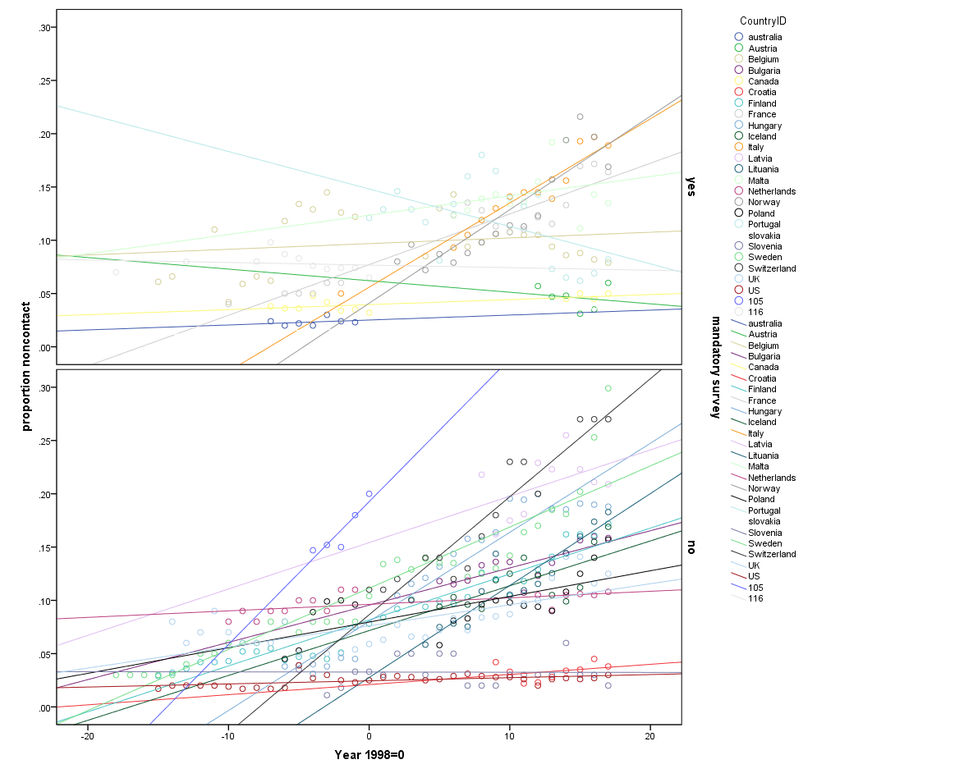
Figure 1. Combined data, noncontact against year code, separate graphs for mandatory and voluntary surveys. The de Leeuw and de Heer data have negative year codes.

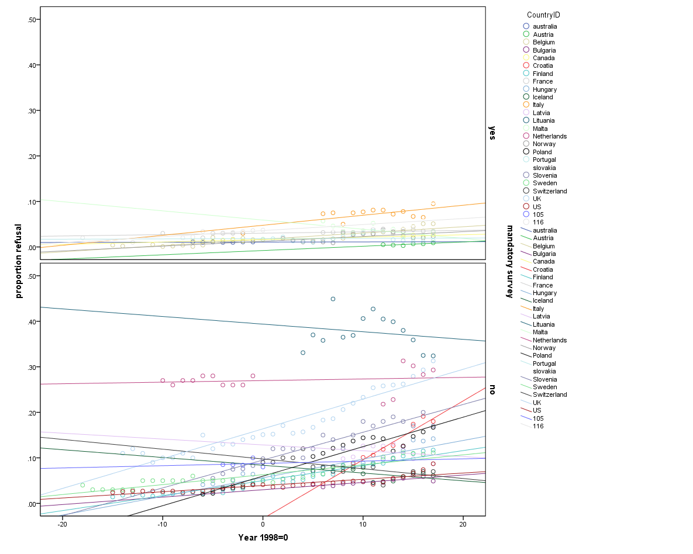
Figure 2. Combined data, refusal against year code, separate for mandatory and voluntary. The de Leeuw and de Heer data have negative year codes.

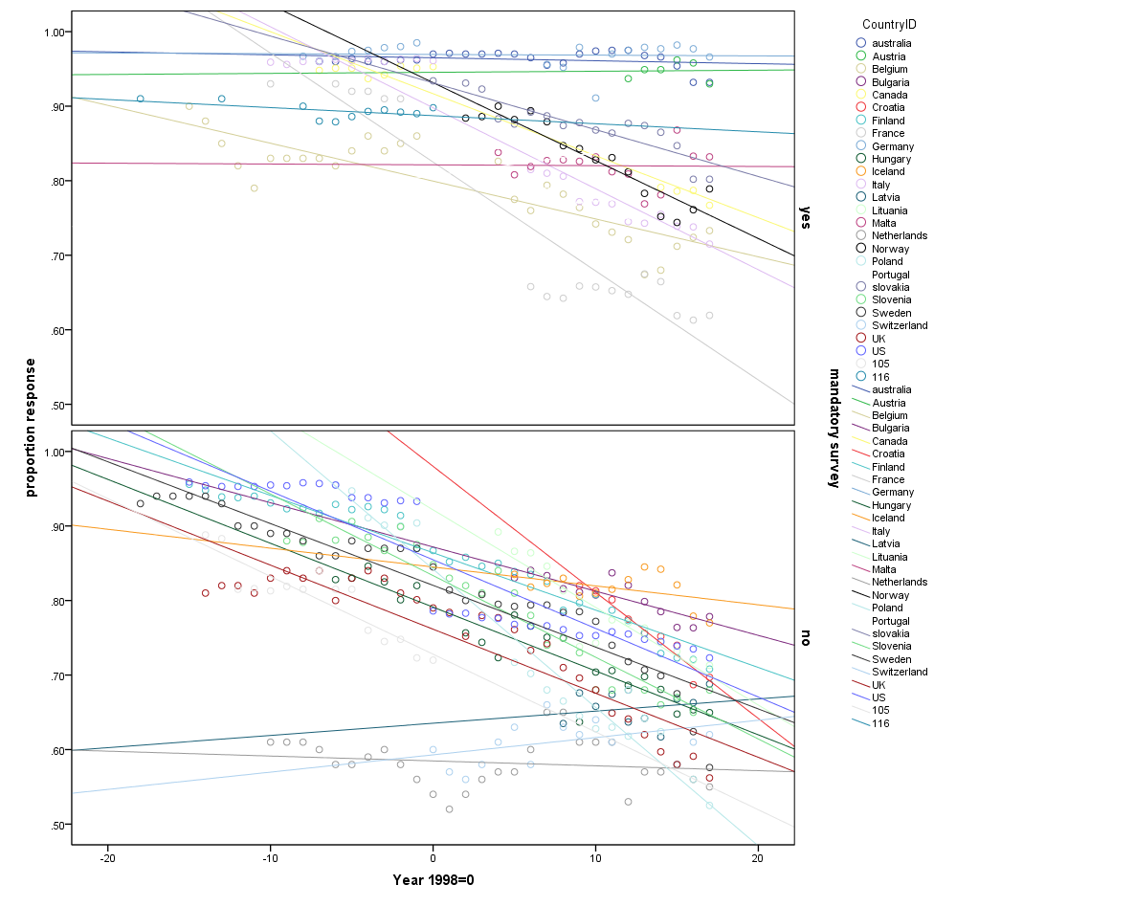
Figure 3. Combined data, response against year code, separate for mandatory and voluntary. Note de Leeuw and de Heer data negative year codes.

Results multilevel regressions Response Logit, combined data. Estimates and (standard errors)
 | de Leeuw & de Heer | Luiten et al | Combined
Intercept | 1.768 (.255) | 1.561 (.159) | 1.670 (.150)
Year | -0.021 '(.014) (ns) | -0.032 '(.008) | -0.046 '(.008)
Mandatory | 0.842 (.369) | 0.314 (.127) | 0.443 (.149)
 | 0.019 (.002) | 0.032 (.003) | 0.052 (.003)
 | 0.618 (.247) | 0.524 (.163) | 0.472 (.143)
 | 0.0027 (.00119) | 0.0014 (.00047) | 0.0016 (.00048)

Results multilevel regressions Refusal Logit, combined data. Estimates and (standard errors)
 | de Leeuw & de Heer | Luiten et al | Combined
Intercept | -2.550 '(.220) | -2.734 (.230) | -2.688 (.199)
Year | -0.054 (.015) | 0.034 (.010) | 0.034 (.008)
Mandatory | -1.172 '(.349) | -0.777 (.147) | -0.881 (.170)
 | 0.093 (.012) | 0.041 (.004) | 0.063 (.005)
 | 0.404 (.290) | 1.075 (.381) | 0.862 (.284)
 | 0.0020 (.00114) | 0.0018 (.00067) | 0.0014 (.00049)

Results multilevel regressions Noncontact Logit, combined data. Estimates and (standard errors)
 | de Leeuw & de Heer | Luiten et al | Combined
Intercept | -2.719 (.224) | -2.592 ' (.148) | -2.600 ' (.142)
Year | 0.032 (.014) | 0.031 (.008) | 0.034 (.007)
Mandatory | 0.002 (.298) (ns) | -0.091 '(.140) (ns) | -0.140 '(.150) (ns)
 | 0.042 (.006) | 0.041 (.004) | 0.054 (.004)
 | 0.521 (.209) | 0.397 (.132) | 0.404 (.122)
 | 0.0020 (.0012) | 0.0012 (.00042) | 0.0011 (.00035)

Figure 4. Response trends in other social surveys

Statistics Netherlands
Utrecht University

